**Annual Report 2023 – 2024**

**Staff Changes, Achievements, and Future Directions**

The past year has been one of considerable change for CILPK, marked by staff transitions and notable developments within the organisation. These changes have played a significant role in the continued growth and advancement of our charity, and we are proud of the progress we have made.

**Staff Transitions**

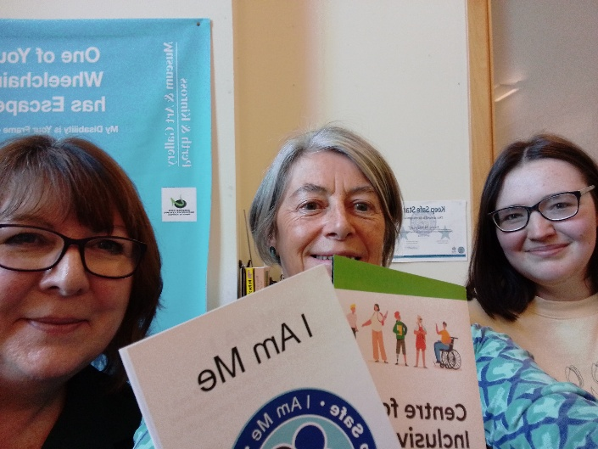

At the end of last year, our Administrator, Axelle, was due back from her maternity leave, but, understandably, made the decision to step-down from her position, in order to devote more time to her newborn son, Alexis. We are grateful for her contributions to the charity and wish her all the best as she embarks on this new chapter.

In response to Axelle’s departure, Sheila joined CILPK, initially as Acting Administrator, to cover her maternity leave, until Axelle left, when Sheila took on the role fully. Sheila’s expertise and commitment have made her an invaluable asset to our team. Additionally, we welcomed Rowan, funded through the National Lottery Community Fund, to assist with the ongoing development of our ‘*Keep Safe Scheme’*, a critical initiative designed to ensure the safety and inclusion of vulnerable individuals within our community. The two main objectives for this post were to revisit existing Keep Safe premises, providing refresher training to new and existing staff as well as to spread the word about what the Keep Safe Scheme is all about around groups and organisations who may benefit from it.

We also bid farewell to Jane, our Manager, who will be leaving us in December. Jane has been a dedicated and inspiring leader during her tenure, and we are grateful for her unwavering commitment to our mission. We are delighted that Sheila will be stepping into Jane’s role, and as a result, we will now be looking to recruit a new Administrator.

This year, we have seen a significant organisational shift as we relocated our offices from Tay Street to The Gateway Centre. This move has afforded us enhanced facilities and improved accessibility, enabling us to better serve our members.

Despite the challenges posed by these staff transitions, we have continued to deliver high-quality services and have successfully launched several new initiatives that have further strengthened our position within the community.

**Achievements and Impact**

One of our key priorities this year has been increasing member engagement, particularly among those who have been long-term supporters of CILPK. We have witnessed a significant rise in participation, especially in our online sessions, which has enabled us to reach more individuals and foster deeper connections within our community.

A central focus of our advocacy work has been the promotion of a holistic understanding of disabilities, particularly the intersection of mobility and sight loss. As a trustee, I have remained committed to ensuring that CILPK takes a comprehensive approach to addressing the combined needs of individuals living with multiple disabilities. Our goal is to move beyond single-issue approaches and champion inclusive solutions that cater to the diverse needs of our members.

**Key Programmes and Initiatives**

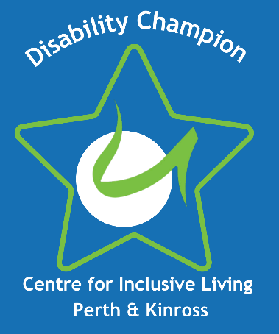

In 2023, we proudly launched our ‘*Disability Champion Programme’*, which provides our members with the opportunity to play a more active role in shaping the direction of CILPK and its activities. This programme has allowed us to introduce a new logo, designed by the group, which now features on our branded fleece jackets. One of the aims of this programme was to ensure that our members are truly at the heart of everything we do. By providing support and encouragement our members are empowered to take on new challenges, have a say in the things that matter to them and help to shape future activities. We are delighted to have seen a couple of our members step into a Trustees role and take on additional responsibilities as well as an increase in the number of members who are actively contributing to our members newsletters.

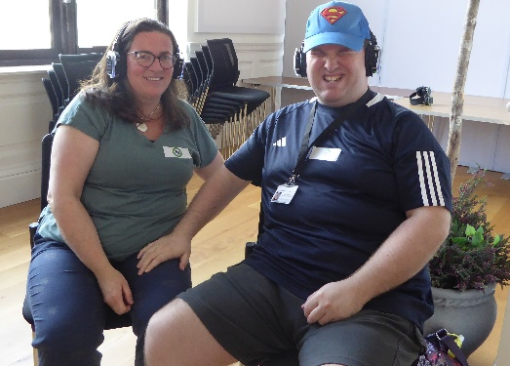

As part of ‘*Learning Disability Week’*, we hosted a range of events, including our first-ever *Silent Disco*, which was met with great enthusiasm and enjoyed by all who attended. We also hosted *Come and Try* sports activities, reinforcing our commitment to promoting inclusivity within the community.



A particularly significant achievement this year was the launch of our ‘*Hear Our Roar’* campaign, which seeks to amplify the voices of individuals with learning disabilities in the local community.   
This initiative includes the establishment of a local network group, designed to empower individuals and give them a platform to advocate for their rights and needs. This project has been a good example of collaborative working with the Health and Social Care Partnership who received funding to run the project with our involvement. It is an exciting time for this group as they look towards electing a Chair and Co-Chair to support the activities going forward.

**Collaborations and Advocacy Efforts**

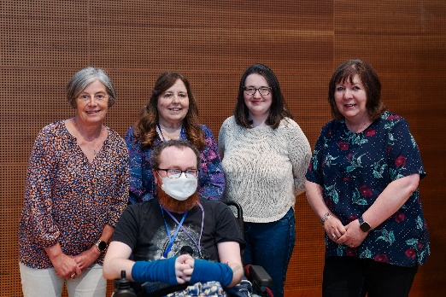

Jane, representing CILPK, was honoured to provide the keynote address at the ‘*Disability Equality Scotland’* conference in Perth, where we shared our insights and advocated for a more inclusive society for disabled individuals. We also continued our collaboration with Perth & Kinross Council on the introduction of the new pavement parking ban, which has now been implemented across Scotland. This initiative aims to improve the accessibility of public spaces for people with disabilities and is a vital step toward creating a more inclusive environment.

**Inclusive Communication and Disability Awareness Training**

CILPK continue to work in partnership with Perth & Kinross Council to deliver this training. We were delighted to work specifically with the internal IT and media team this year and hope that some of the scenarios and useful tips offered by our members will help them provide more inclusive outward facing communications.

We also provided wider training which also included individuals from other 3rd sector organisations. The success of these sessions is as much about learning from other participants experiences as well as from our members with disability lived experience and from the facilitator.

**Access Audits**

CILPK continue to provide access audits to a variety of organisations and this year saw an increase in our involvement in this respect. We provided a range of audits including football clubs, the new Perth Museum, YMCA Y Centre, Caledonia Housing Association offices, St Johns Kirk, Pullar House and the Crieff Musuem. These audits remain an important part of what we do as our members who are involved can offer some good practical information and advice that falls out with legislation and tick box type approaches.

**Communication with our Members**

Involving our members remains a key priority for us as an organisation and ensuring we do this well and inclusively means we have been trying to establish and understand our members’ communication preferences. Whilst we can always do this better this year has seen an improvement in our member engagement overall suggesting that we are reaching our audience better through a variety of different mediums.

Re-introducing our digital newsletter with a range of information and including our members’ stories and spotlights.

**In Memoriam**

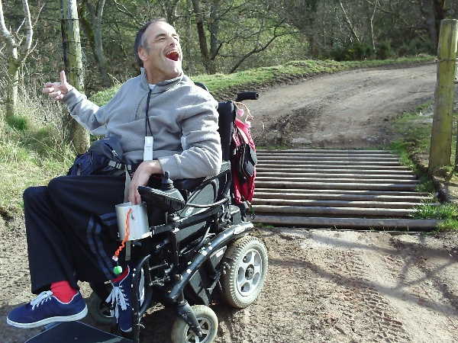 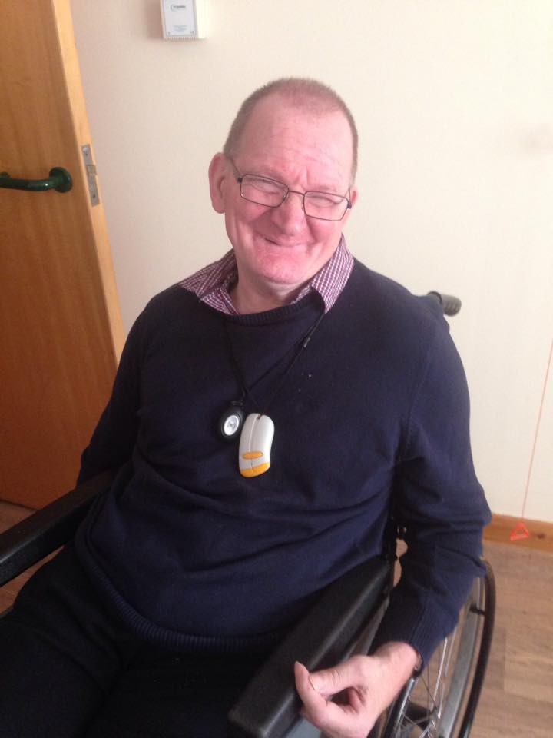

This year, we sadly lost two esteemed members of our community: Bob Bennett and John Spence. Bob was a long-standing and active member of CILPK, contributing in numerous ways to our work and the broader Perth community. His passing has left a profound impact, and he will be deeply missed by all who knew him. Similarly, John Spence, another valued member, passed away this year. Our heartfelt condolences go to their families and friends during this difficult time. Both Bob and John will be fondly remembered for their dedication to CILPK and the positive impact they had on our work.

**Looking Ahead**

As we reflect on the year’s achievements and challenges, we are filled with a deep sense of gratitude for the continued support of our staff, trustees, and members. Despite the changes and transitions, CILPK has really grown up as a charity, and remains a strong and resilient organisation, committed to advocating for the rights of people with disabilities and providing a platform for their voices to be heard.

Our Service Level agreement funding from Perth & Kinross Council is very much appreciated as it allows us to continue our core activities on a sure footing. In addition, we were delighted to receive National Lottery Community Funding and have reapplied for more next year. In addition, we are waiting to hear about a Gannochy Trust fund application and if successful would allow us to recruit a part time outreach worker.

I would like to express my sincere thanks to Jane for her exceptional leadership and dedication to CILPK. Her contributions have been instrumental in driving the organisation forward, and we wish her much success and happiness in her future endeavours.

We look forward to the coming year with optimism and determination, as we continue to build on the foundations of this year’s achievements and work towards an even more inclusive future for all.

**Cindy Godfrey-McKay**

**CILPK Chairperson**